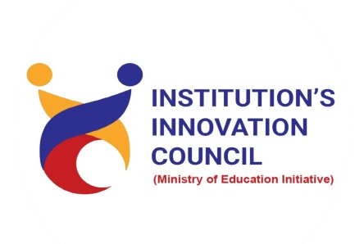
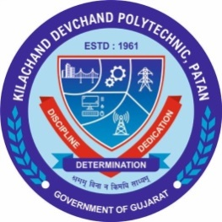

Student start-up research and innovation Cell

K. D. Polytechnic, Patan

One day Seminar on
“Basics of Arduino”

Date
05/12/2023
Tuesday
01:00 PM to 03:00 PM

Program Report

- DETAILS OF PROGRAM
Title of Program: | One Day Seminar on “Basics of Arduino”
Date: | Tuesday, 05/12/2023
Time: | 01:00 pm to 03:00 pm
Venue: | Seminar Hall  K. D. Polytechnic, Patan.
Event Coordinator | Dr. Hitesh R. Patel  Mr. A. R. Joshi  Mr. Hiren R. Patel
Speakers: | - Mr. U. V. Patel,  Lecturer, E. C. Engineering Dept. K. D. Polytechnic, Patan  - Mr. S. V. Patel  Lecturer, Electrical Engineering Dept. K. D. Polytechnic, Patan
Participant: | First Year Students (All Department)  K. D. Polytechnic, Patan  62 Mechanical + 26 Electrical  = 88 Students.

- Brief about program
The Student Start-up and Innovation Policy (SSIP) Cell at K. D. Polytechnic is dedicated to fostering a culture of innovation and entrepreneurship among students. Through workshops, mentorship, and networking opportunities, the SSIP Cell empowers students to pursue their entrepreneurial aspirations and contribute to economic growth.
To improve innovativeness and entrepreneur skill among students SSIP Cell have organise seminar based on Arduino. Learning Arduino is highly valuable for engineering students; Arduino projects often involve a combination of electrical engineering, computer science, and mechanical engineering concepts. This interdisciplinary approach encourages students to integrate knowledge from various fields, mirroring the collaborative nature of many engineering projects. Hence can increase innovative thinking among students about life application. More than 90 students have participated in this event.
- Glimpse of program
Brief About SSIP 2.0 Policy and program by SSIP Coordinator Dr. H. R. Patel
Glimpse of Session Delivered by Mr. U. V. Patel,
Glimpse of Session Delivered by Mr. S. V. Patel,
Demonstration about use of Arduino UNO

